EAM: Emergency Access Management

VIRSA 4.0 ------> Fire Fighter (FF)
GRC AC 5.1, 5.2, 5.3 ------- > Super user Privilege Management (SPM)
GRC AC 10, 10.1,12 -------> EAM

Background of this Concept:
- 70% of the Authorizations, assigned to user, were never used by User.
- Within the Authorization used by user, 15 – 20% of the Authorizations are rarely used

T-codes have been categorized as below
- Daily used – Assigned to user on permanent basis (70% T-codes) Ex, SU01, PFCG, SU10, PFUD, and SUIM…..
- Rarely used = Critical – this access would be assigned only when required and requested by user (30% T-codes) Ex, SU25, SU24, SU20, SU21

Firefighter Concept based on granting/providing access:
ID based
Normal user id will be linked to FF ID (which has critical Access assigned) for short duration – 1 to 5 days
Role Based
FF role will be assigned to Normal user based on the request and also for short duration - 1 to 5 days

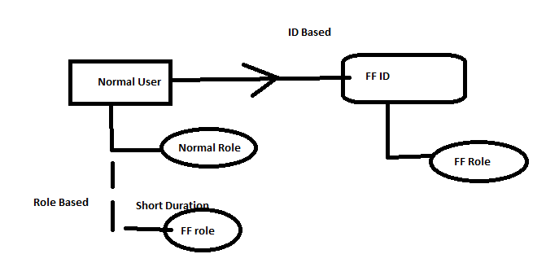
To use Critical T-codes assigned to user through FF ID, user has to launch the EAM/FF Launch Pad
This can be launched in 2 ways
- GRC system ------- > Centralized FF ID Concept
- Plug in system (S4HANA/ECC/BW) ------- > Decentralized FF ID Concept

FF ID Concept based on Login:
- Centralized FF - Login from GRC system – GRAC_SPM or GRAC_EAM (T-codes)
- Decentralized FF – Login from Plug In system and execute T-code /n/GRCPI/GRIA_EAM
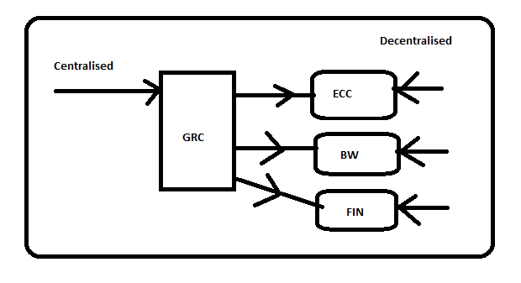
Possible concepts in EAM:
1. ID Based (Launch pad Concept)
- Centralised FF Concept (User should exist in GRC)
- Decentralised FF Concept (User should exist in Plug in system)
2. Role Based (No Launch pad Concept)

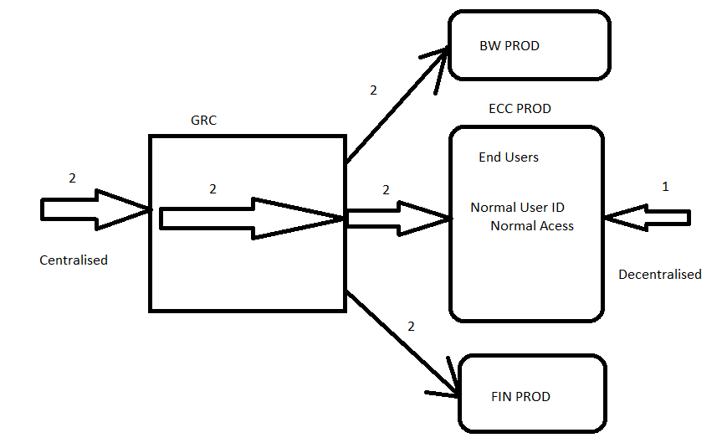

In VIRSA 4.0 and GRC 5.1, 5.2, 5.3 ---- > DECENTRALISED Concept
In GRC 10 SP01 to SP09 ------> CENTRALISED concept
In GRC 10 SP10 and above --- > CENTRALISED & DECENTRALISED concept
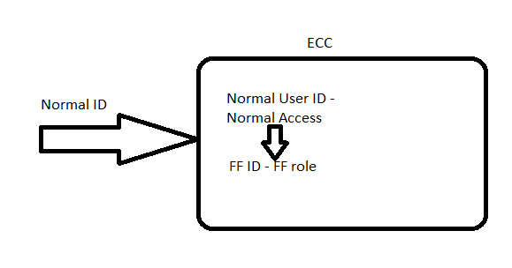
 | GRC | Plug In (ECC)
Centralized FF ID Based | Owner, Controller, FF | FF, FF ID
Decentralized FF ID Based | Owner, Controller | FF, FFID
Role Based | Owner, Controller | FF, FF Role

Centralized- ID based firefighting concept set up:
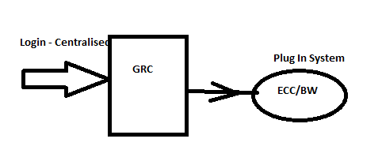
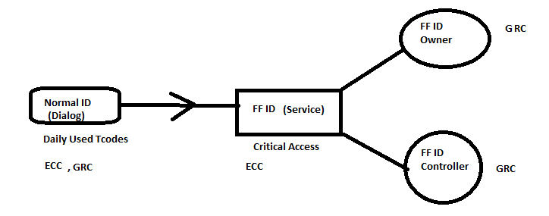
- We need following ids as mentioned below
GRC system – FF, FF ID Owner, FF ID Controller
Plug in System (ECC) – FF, FF ID
ID Based:
- Firefighter – Normal User (dialog) or person who uses FF ID. Ensure FF has access to Launch Pad T-code in GRC system: GRAC_EAM or GRAC_SPM
- FF ID – Special id which is of Service User Type assigned with critical access(FF ROLE) and SAP_GRAC_SPM_FFID: Role that has to be assigned to every FF ID
- FF ID Owner – Person who approves FF Access to user and also responsible for assigning FF ID to normal user
- FF ID Controller – person who monitors the activity done by user (FF) using the FF ID
Role Based:
- FF
- FF Role (ROLE)
- FF Role Owner
- FF Role Controller

- Define /Declare FF ID Owner and FF ID Controller in the Set Up ---- > Access Control Owners link. (not required in GRC 12)
NWBC ------> Set Up ----- > Access Owners

- Mapping FF ID Owner and FF ID controller to the FF ID
NWBC ---- > Set Up ---- > Super User Assignment ------ > Owners
NWBC ---- > Set Up ---- > Super User Maintenance ------ > Controllers
- Define Reason Codes
NWBC ---- > Set Up ---- > Super User Maintenance ------ > Reason Codes
FF ID Linking with Normal User is done in 2 ways
- Manually - Approval and Linking
- Automated – Workflow - ARM

- Linking FF ID with FF (normal user id)
NWBC ---- > Set Up ---- > Super User Assignment ------ >FF IDs
Or
NWBC ---- > Set Up ---- > Super User Maintenance ------ > Firefighters
FF Logs:
Path: NWBC --→ Reports & Analytics ---- > EAM reports ----- > FF log Report
FF logs will be reviewed by the controller

De-Centralised ID Based Fire fighting Concept:
- 4015 parameter – enable it - YES
- Create all required users in GRC (FFID Owner and FFID Controller) and ECC system (FF, FFID). Ensure FF has access to Launch Pad T-code: /n/GRCPI/GRIA_EAM in Plug in System
- Mapping FF ID Owner and FF ID controller to the FF ID
NWBC ---- > Set Up ---- > Super User Assignment ------ > Owners
NWBC ---- > Set Up ---- > Super User Maintenance ------ > Controllers
- Define Reason Codes
NWBC ---- > Set Up ---- > Super User Maintenance ------ > Reason Codes

- Linking FF ID with FF (normal user id)
NWBC ---- > Set Up ---- > Super User Assignment ------ >FF IDs
Or
NWBC ---- > Set Up ---- > Super User Maintenance ------ > Firefighters

- Additional Config in ECC system:
Local RFC has to be created
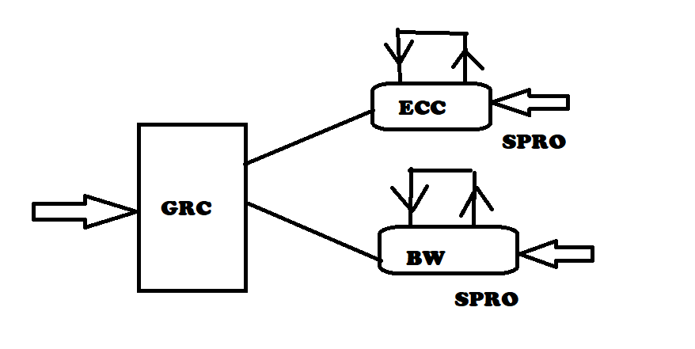
SPRO --- > GRC (Plug-In) ----- > Access Control ---- > Maintain Plug-In Configuration Settings

1000 Parameter – Maintain Local RFC Name pointing to same system and it is similar to your Connector name between GRC and Plug in System.

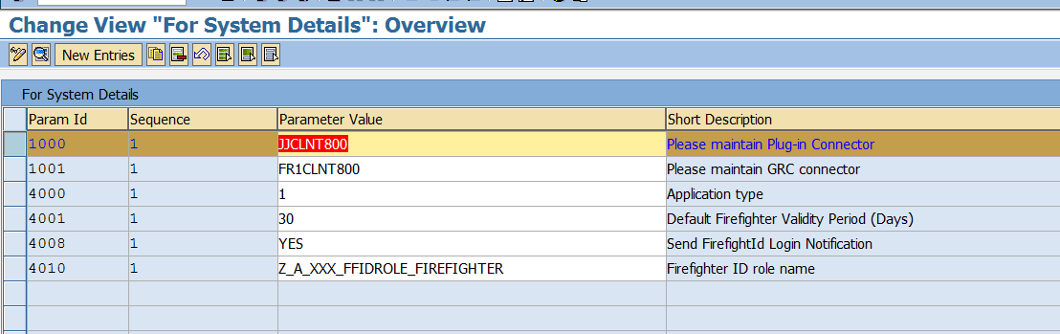

- Sync Job – EAM_MASTER_DATA_SYNCH – run this job for only for De-centralised Concept.
Role based Fire fighting Concept:
- Define 4000 Parameter
- Role is created in BRM with setting ENABLE for FIRE FIGHTING
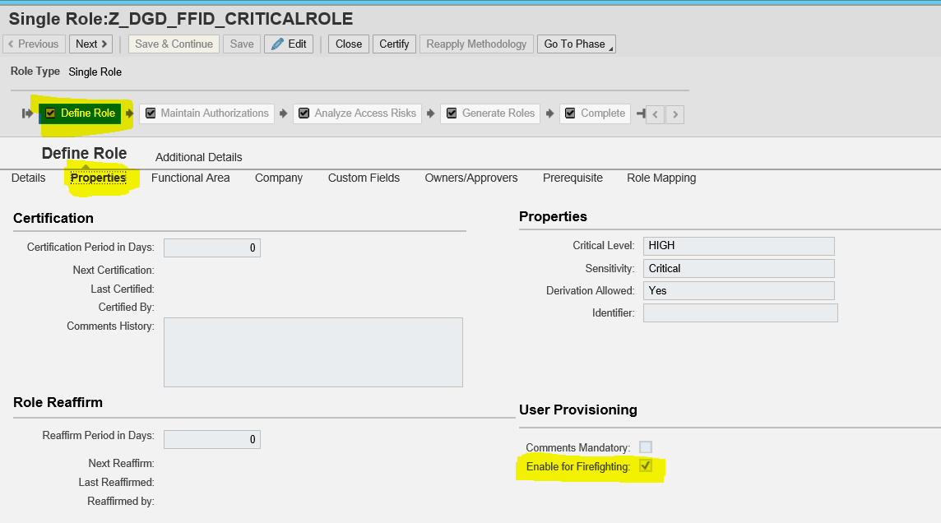
- Ensure user ids are existing for FF ROLE OWNER and FF ROLE CONTROLLER.
- Declare them under SET UP --- > Access Control Owners (Not required in GRC 12)
- Mapping of FF ROLE with FF ROLE OWNER and FF ROLE CONTROLLER
- Linking FF ROLE to the FF (Normal User)
- User can login into ECC and perform the Fire fighting Concept
If the FF ID is not visible in GRC system what could be the Reasons?
- 4010 Parameter role - SAP_GRAC_SPM_FFID is not assigned to FF ID
- Repository Sync job is not run after creating FF ID and assigning the above role
ZSAP_GRAC_SPM_FFID: Role that has to be assigned to every FF ID.
Whichever role is mentioned in parameter 4010, that role has to be assigned to every FF ID in plug in systems.If this is custom role, that should be copy of SAP_GRAC_SPM_FFID

Imp parameters related to EAM:
4000 Series is related to EAM/FF
4010: FF ID role - SAP_GRAC_SPM_FFID (Identifier Role – Which ever user id is assigned with this role, that ID is considered as FF ID in GRC system)
4000: ID based or Role based
4001: Default Firefighter Validity Period (Days)
4015: Activate Decentralized
Note: 4015 Parameter was launched from SP10 in GRC 10 and above. Earlier to that, only centralized concept is available by default.

Disadvantage of Role Based:
- User is confused or not conscious about using the FF role

GRC Centralized (ID Based)
***********************
User1 ---- > GRC GRAC_SPM/EAM -----> Logon Pad ----> ECC New Screen (FFID)

Decentralized - ECC (ID Based)
***************************
User1 -----> ECC /GRCPI/GRIA_EAM ------> Logon Pad ----> ECC New Screen (FFID)

Role Based
***************************
User1 -----> ECC GUI ----> Same Screen User1

Disadvantages of ID Based:
- Sequence of steps in a t-code or internal calling of t-codes
EX,, LSMW or SM30/SE16

Disadvantage of Centralized FF concept:
- When GRC system is down, FF concept cannot be used in any plug in system.
- All the users who ever wants to use FF ID in Plug in systems, they should also exist in GRC system
- User who does not exist in Plug in system(ECC), can still use the FF ID in the Plug in system(ECC)

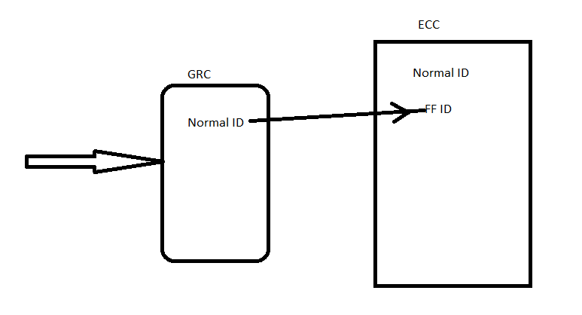
BASIS Team
- FFID_BASIS1
- FFID_BASIS2
- FFID_BASIS3
Finance Team
- FFID_FIN1
- FFID_FIN2
- FFID_FIN3
Some Clients have dedicated FFID to every user in the Org
- U1 : FFID_U1 --- > One year
- U2 : FFID_U2
- U3 : FFID_U3
SAP_ALL should not be assigned to FF ID?
(Daily used t-codes should not be assigned to FF ID)
- There is no use of creating separate FF ID team wise. Segregation (SOD) is not possible.
- Unnecessary logs will be generated and it is difficult for Controller to monitor. He will lose interest in reviewing the logs.
Advantages of FF concept:
- Tracking the usage of critical T-Codes
- Minimize the total Access risk count in the organization – Risk Analysis
Disadvantages of EAM:
1. Not possible in JAVA/ABAP Web Dynpro based systems
2. Hour based FF ID access cannot be granted (ER Emergency Repair -Security Weaver)

FF LOGS:
NWBC ----- > Reports & Analytics ------ > EAM Reports
- FF log Summary Report

Try this: Assignment
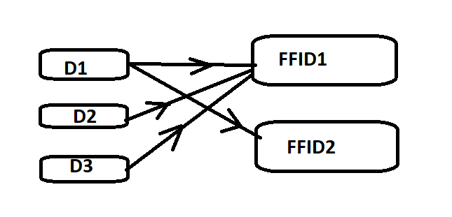

New Features in GRC 12 for EAM:
- No need to maintain EAM approvers in Access Control Owners Link
- EAM concept can be used in HANA Database level – HANA DB – We have concept of Privileges (T-codes). It will record privileges.
Ex,, System privilege ---- > User Admin – Create User, Modify User, Delete User
System privilege ---- > System Admin ---- >

